Seattle Fire Fighters Union Local 27
2021 Candidate Endorsement Questionnaire
(City of Seattle)

- Campaign Information

Candidate Name __________________________________________________________

Position Sought __________________________________________________________

Campaign Committee Name_________________________________________________

Address _________________________________________ Zip code _______________

Campaign Phone Number __________________________________________________

Other Phone Number ______________________ Fax Number____________________

Email Address ___________________________________________________________

Website Address __________________________________________________________

Facebook _______________________________________________________________

Twitter _________________________________________________________________

Campaign Manager Name__________________________________________________

Campaign Manager Phone Number ___________________________________________

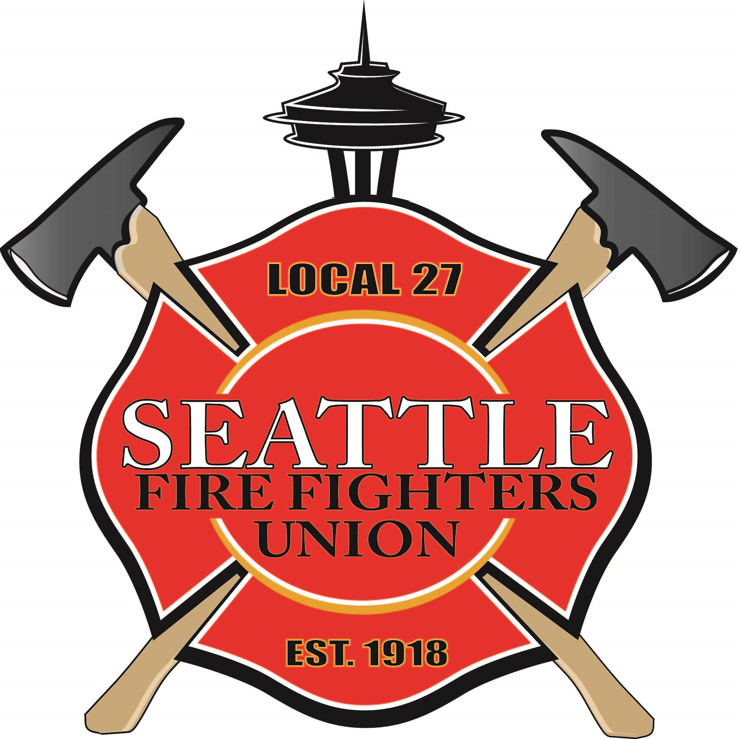
Campaign Information

- Have you ever run for or held an elected office? (please circle one)

Yes No

- If so, did you receive the endorsement of Local 27 or another IAFF affiliate?

Yes No

- If so, did you receive the endorsement of any labor organizations? If yes, please list.

Yes No

- Have you received the endorsement of any labor organization(s) for your current campaign? If yes, please list.

- Please describe your campaign manager’s experience.

- Please identify your campaign consultant(s).

- Do you have a written campaign plan?

- What is your campaign fundraising goal?

- Please briefly describe your campaign budget.

- What other endorsements have you received to date?

- What other endorsements do you expect/want to receive?

- What role will public safety issues play in your campaign? Please provide details.

- Describe any union experience and or past support for the labor movement.

- Priorities

- What will your priorities be if elected?

- What are the most significant issues facing Seattle?

- What committees are you interested in serving on?

- Please explain what Public Safety means to you and what public safety issues will you focus on if elected?

- What labor issues will you focus on if elected?

- What issues are you aware of that are challenging the Seattle Fire Department and Seattle Fire Fighters and how you would address these issues as an elected official?

- If elected, will you meet or respond to Seattle Fire Fighters in a timely manner when we request it due to a concern or question?

- Prioritizing Public Safety and Basic Services
Public Safety is a basic service and core function of any municipal government. However, while the City of Seattle has grown astronomically, and the number of emergency responses has increased with that growth in both number and type of response, the Seattle Fire Department has remained relatively static. In fact, the fire department has fewer fire fighters than in previous years. In addition, roads are deteriorating, and public spaces are becoming unusable.

If elected, list some specific examples of how you will prioritize public safety and basic services.

- Seattle Fire Fighter Issues

Covid-19
The Covid-19 Pandemic has caused a multitude of significant impacts to everyone in our community. Not only are people getting sick and dying, but the economic and social impacts have been unprecedented. In addition, fear and anxiety are prevalent. Throughout this crisis, Seattle Fire Fighters have not wavered. They have demonstrated their commitment to serve, in spite of the significant health and safety risks by organizing COVID-19 Testing Sites, testing more than a half a million people, and operating mobile vaccination teams and pop-up vaccination sites to fight the pandemic.

If elected, how will you support staffing levels for the fire department that ensures the resilience necessary to meet the unpredictable challenges of our growing city?

Seattle Fire Fighters have been responding to patients without interruption since the beginning of the COVID-19 pandemic. Every day we work with patients who test positive for COVID-19. The Seattle Fire Department has ceased notifying fire fighters of hospital confirmed cases of COVID-19, so fire fighters are not “made” aware of their potential exposure to the COVID-19 virus. Furthermore, when Seattle Fire Fighters experience any COVID-19 symptoms (for example: a cough, headache, runny nose, sore throat, etc.), they are required to stay home but they are denied coverage by their employer and must use their own personal sick leave.

On April 10, 2020, Governor Jay Inslee sent a memo to Joel Sacks, Director of the Washington State Department of Labor & Industries (L&I) reiterating that, "...L&I would take steps to ensure workers’ compensation protections for health care workers and first responders who are on the front lines of the COVID-19 (coronavirus) outbreak." In the memo, Governor Inslee recognized that healthcare workers, including fire fighters, "...are working every day with COVID-19 patients" and he stated that, "The practices you have implemented, which assume these individuals’ exposure meets workers’ compensation criteria, unless there is evidence that no on-the-job exposure occurred, are necessary and should continue..." The practice of "assuming that an exposure meets workers’ compensation criteria, unless there is evidence that no on-the-job exposure occurred", is called "presumptive coverage." Fire fighters benefit from presumptive coverage for several hazards we regularly encounter as part of our job, including lung disease, heart attacks, PTSD, and cancer.

If elected, will you ensure that Seattle Fire Fighters receive the presumptive coverage for COVID-19 related illnesses as directed by Governor Inslee?

Fire Fighter Mental Health and Suicide
On the job stresses have a direct link to a high rate of PTS (Post-Traumatic Stress), ASD (Acute Stress Disorder), PTSD (Post-Traumatic Stress Disorder), and suicide for fire fighters and Paramedics. The Seattle Fire Department has had too many suicides over the years and experienced two suicides within 12 months in 2016. Post-traumatic stress (PTS) is a normal reaction to any event that exhibits violence or the loss of life, including many of the responses fire fighters go on. Symptoms usually subside within a few days or weeks and do not significantly impair daily functioning. ASD and PTSD are not normal and cause significant impairment. Research has shown that fire fighters have a higher rate of PTSD than the general population. According to the American Psychiatric Association, the rate of post-traumatic stress disorder (PTSD) in the general population ranges from seven percent to nine percent. Various research studies pertaining specifically to fire fighters have cited PTSD rates for fire fighters ranging from 16 percent to as high as 24 percent. Most people associate PTSD with the military (combat veterans). It has been referred to as “shell shock” and “battle fatigue.” The use of these terms has been slowly fading as public awareness of PTSD has increased. It is difficult to determine the number of fire fighters who have PTSD. Many firefighters will not admit they have PTSD due to the social and professional stigma attached to psychological issues. In addition, fire fighters are typically concerned that seeking help for mental health issues could negatively impact their careers.

If elected, how will you support efforts, resources, and funding for programs to protect and improve the mental and emotional health of fire fighters?

Assaults on Fire Fighters
Seattle Fire Fighters Union, Local 27 has multiple fire fighters who have sustained injuries due to being assaulted by individuals while providing emergency care. Assaults on fire fighters and paramedics have been escalating over the last couple of years. One of the fire fighters who was assaulted during an EMS response sustained serious injuries that almost ended his career. In addition, individuals who assault a fire fighter or paramedic are not held accountable and charged appropriately for this crime.

If elected, how will you support efforts to reduce assaults on fire fighters?

If elected, can we count on you to support legislation that sends a strong message that assaulting fire fighters will not be tolerated in Seattle?

Post-Retirement Medical Coverage
Fire fighting is a dangerous, labor-intensive, and physically demanding job that requires a high degree of skill and efficiency.

Fire fighters are typically unable to work effectively beyond their mid-fifties. Furthermore, fire fighters are more susceptible to certain types of cancers.

Medicare coverage does not begin until 65. Thus, after many years of dedicated service most Seattle Fire Fighters must provide their own medical coverage for up to 14 years after retirement creating a significant financial impact at a time when fire fighter’s health is at risk.

Post-retirement healthcare from retirement until Medicare is a significant financial burden that is unusual for most workers.

If elected, will you support efforts to support the healthcare coverage needs of fire fighters between retirement and Medicare?

West Seattle Resources – Ladder 13

When the West Seattle Bridge was closed in 2020 after dangerous cracks were discovered the city placed an additional ladder company in West Seattle to ensure that people in West Seattle and South Seattle would have the resources they need when seconds count. The city has known for years that a ladder company was needed in this area, in fact, studies commissioned by the city recommended additional resources there. The people South of downtown need and deserve the same level of resources as the rest of the city. In addition, training, traffic, and other challenges are putting more pressure on fire suppression resources.

If elected, will you support efforts to fund and maintain Ladder 13 in West Seattle?

SFD Uniformed Dispatchers
Seattle has one the best and most responsive 911 operations in the nation. One significant reason for this is that Seattle has experienced uniformed fire fighters answering 911 calls and dispatching aid. Having experienced fire fighters as 911 Dispatchers allows the fire fighters on scene and those they are helping get the proper resources. Having experienced fire fighters as 911 Dispatchers is also important because their experience is critical in the allocation of the City’s finite fire protection and life safety resources. In other words, making sure that the proper apparatus and personnel are dispatched to the most serious aid calls.

If elected, will you oppose elimination of uniformed fire fighters as Dispatchers at the Seattle 911 call center?

Fire Department Staffing Needs
Demands on the Seattle Fire Department continue to increase at an alarming rate. Seattle has experienced unprecedented growth and was the fastest growing city in the United States from 2010 to 2018, adding 116,000 more citizens, which is an 18.7% increase in population. This is Seattle’s greatest rate of growth since the Klondike Goldrush in 1896.

Over the years fire department resources have been reduced overall. Normally when a single unit approaches 3500 responses annually, additional resources are considered. SFD has single units responding to 4,000, 5,000, 6,000, 7,000 and over 8,000 responses annually. This is not sustainable.

In addition, our job continues to become more complex, and the department is pursuing a Class 1 ISO Rating and has increased training hours by 50%. This means our current resources are available less of the time. We must provide the necessary resources to keep pace with the growing demands of our thriving city. Services must be properly prioritized and maintained at the required minimum levels.

Furthermore, the number of individuals living on the streets in Seattle has increased dramatically over the last few years. Seattle Fire Fighters serve every member of our community without regard to residence, financial status, immigration status, or any other criteria. We respond 24 hours a day to tents, RV’s, alleys and parks as well as to homes, hotels, and businesses. We serve those living on the streets of Broadway and Belltown as well as those living in the homes of Broadmoor and Blue Ridge. We respond daily into unauthorized homeless encampments to answer the calls of the people living there. These responses have increased dramatically and have become more challenging in many ways, Mental Illness, substance abuse, violence, criminal activity, unsanitary and unhealthy conditions, human waste, and access are a few of the challenges fire fighters face daily to serve this population.

Meanwhile, over the years staffing in the department has not kept up. The growing number of vulnerable Seattle residents including the elderly, people with mental health issues, people with drug and alcohol addictions, and the people living on the street are inundating Seattle’s fire fighters with 911 calls that are not acute emergencies although they are in need of help. 911 is oftentimes the primary source of medical care for some of these populations. When fire fighters respond to these calls, they are no longer available for more time-sensitive critical emergencies.

The Seattle Fire Department has implemented Health One to increase our ability to respond to these “low acuity” incidents in a manner that reduces our dependence on our emergency resources and provides the best service to these people. We are in the process of expanding this program by adding two additional Health One units.

If elected, will you oppose any reductions fire department staffing and services?

If elected, how will you support increases to fire department staffing?

If elected, will you support the continuation of the Health One Program?

5-Person Ladder Companies
The National Fire Protection Agency (NFPA) sets national standards for the fire service to protect the public and make fire fighters as safe as possible when they do their job. NFPA 1710 sets staffing standards which includes at least four (4) fire fighters on every engine company and ladder company and five (5) fire fighters on ladder companies in high density areas.
These staffing standards are based on studies and determined by a consortium of participants including members of the fire service, municipalities business, and industry professionals. These staffing standards are minimum standards that ensure timely, safe, effective, and appropriate service levels for communities.

With the increases population and density occurring in Seattle 5-person ladder companies become even more important than ever.
If elected, will you support five-person ladder companies where indicated and preserve four-person staffing on every fire engine and fire truck in Seattle?

Collective Bargaining and Arbitration
Collective Bargaining is a critical element of positive and effective labor relations. Public Employee Unions are a great asset in dealing with critical issues such as the severe government budget shortfalls we recently experienced. For example, in their 2008 contract negotiations Seattle Fire Fighters proposed and agreed to forego 2% cost of living increases to help the City of Seattle during the economic downturn. Then again, in the following contract, Seattle Fire Fighters agreed to take significantly less than the cost of living for 2012 and 2013. These collaborative acts saved the City millions of dollars and demonstrated the value of a good relationship with workers. In other parts of the country we have seen more aggressive and antagonistic approaches to dealing with public employee unions that may save some money in the short term, but ultimately will destroy morale, decrease productivity, and set a poor example for all employers.

Our right to collectively bargaining is under attack. Legislators in several states, including Washington, and multiple jurisdictions across this country are working with organizations such as the Freedom Foundation to pass ALEC-sponsored legislation that is detrimental to collective bargaining. The current legislation being pushed by this corporate- funded non-profit calls for public employee collective bargaining sessions to be open to the public in the interest of transparency. This is not about transparency; it is about destroying unions.

The goal of the ALEC legislation is to use the misinformed court of public opinion to cripple public unions and continue the march towards a country where greed has no antidote. ALEC currently has some traction with this model legislation in Alaska, Colorado, Florida, Idaho, Illinois, Iowa, Ohio, Tennessee, Texas, and Washington

We are also aware of efforts to eliminate or modify the right to binding arbitration for police. Fire fighters are adamant that binding arbitration is a useful and necessary tool for reaching compromise at the bargaining table That serves the public’s interests, as well as the interest of the city and fire fighters. This is especially important for fire fighters given that state law provides arbitration in exchange for barring fire fighters from striking. Arbitration provides for a fair mechanism to settle disputes and is a time-tested and transparent process that should be a basic right for all labor unions.

If elected, will you support the collective bargaining rights of Seattle Fire Fighters, City of Seattle employees, and all union employees and oppose any and all legislation, at the City or State level that reduces the rights and abilities of workers to collectively bargain with their employer?

If elected will you oppose efforts or legislation to ‘daylight” or open collective bargaining to the public?

If elected will you oppose efforts or legislation to eliminate, reduce, or modify binding arbitration for labor unions?

So- called “Right to Work”
We have been seeing attacks on Labor Unions nationwide, with States attempting to enact Right-to-Work laws. These laws weaken Unions and significantly reduce an employee’s voice concerning wages, hours, and working conditions.

If elected, will you oppose and work to block any attempt to bring Right-to-Work laws to Washington State?

Safe Injection Sites
Safe- injection Sites have been proposed by some in response to the opioid crisis. Safe-injection sites allow drug addicts to inject illegal drugs intravenously in a public facility. According to Dr. Caleb Banta-Green at the University of Washington, “It (safe-injection sites) may not help with mortality rates. I suspect it does but it’s small. About 1 to 2 percent of opiate injectors die every year. So, you have to be studying thousands of people to see an effect of that.” Opponents of safe- injection sites emphasize the need for treatment facilities and counseling rather than condoning and normalizing this type of drug use.

Fire fighters respond every day to people who use illegal drugs, including intravenous heroin users, and we know that condoning and supporting heroin addiction is the wrong path. Addiction to heroin is only part of the horror we see. Heroin use means crime, incarceration, and criminal predators, job loss, broken families, homelessness, child abuse, child prostitution, and more devastating effects. In terms of harm, allowing heroin addiction to continue creates extraordinary harm in a wide variety of ways.

If elected, what is your position on this proposal?

Unsheltered Outreach
The City of Seattle had a Navigation Team comprised of outreach workers paired with Seattle Police Department (SPD) personnel, to connect unsheltered people existing in unsanitary, unhealthy, and inhuman conditions to housing and critical resources, while helping to address pervasive intolerable situations related to homelessness in Seattle. This team was eliminated in the 2020 budget process.

If elected, how will you address the issue of unauthorized encampments?

If elected, how will you address the impacts of unauthorized encampments on the residents, their neighbors, and fire fighters?

Seattle Fire Fighter Endorsement
Seattle Fire Fighters are involved in the political process to elevate candidates who prioritize public safety and fire fighters.

What would the endorsement of Seattle Fire Fighters Union, IAFF Local 27, mean to you and your campaign?

